- Check how many branches are available
Command : git branch --list
- Add a file to hiring-app

Command: touch hello
Command: git status
Output:
We see two file are untracked
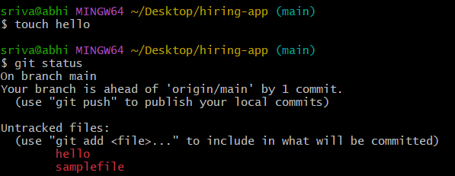

- How to commit untracking files
Command : git add .
Command : git status
Files committed
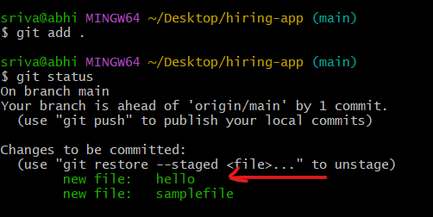

- How to create git branch
Command: git branch release

To check status of existing branches or how many branches available
Command: git branch --list 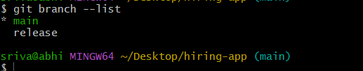

- How to switch one branch to another branch
Command : git checkout release
Command : git branch --list
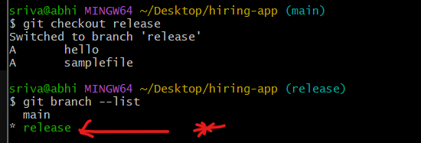

- Now switching from release branch to main branch and creating new file In main branch .
Step:1 switch to main branch
Command : git checkout main
Step :2 Create file in main branch
Command : touch main
Step 3: Add untrack to track file
Command : git add .
Step 4: Add commit
Command : git commit -m “added main file in main branch” 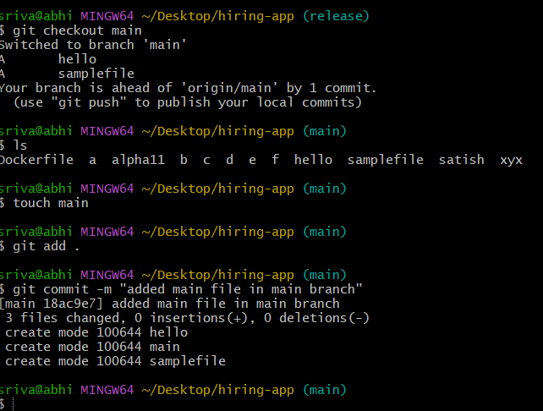
- Now check in release branch file main by switching to relase branch
Step 1: git checkout release
Step 2: ls
Now the file name main is not available in release
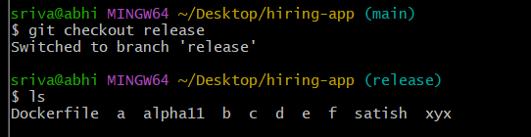

Note:
When you create a new branch, Git creates it from the current branch (or from the commit you specify). At that moment, the new branch contains all the files and commits that exist in the source branch.
After the branch is created:
- Changes made in the main branch are not automatically copied to the release branch.
- Changes made in the release branch are not automatically copied to the main branch.
- To get the latest changes from one branch to another, you must merge or rebase the branches.

- Initialy the code move to develop branch and then release
Develop - release
Create hotfix branch and see file copy from release to hotfix
Command : git branch hotfix
Command : ls
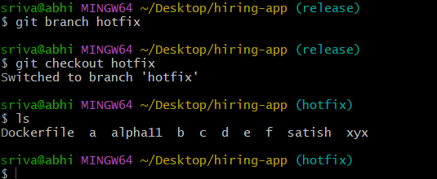

- How to merge code from different branches
Command : git merge

Step 1: created file release in release branch
Command : touch release
Step2: add to track
Command : git add .
Step 3 commit to changes
Command : git commit -m “added file release in release branch”
Step 4 switch to hotfix branch
Command : git checkout hotfix

Step 4 now merge from release to hotfix
Command : git merge release
We can able to see file release in hotfix branch after merge

